Aerohive Networks Inc.
Test Plan for <European product support and auto roaming in LB>

Revision History
Version | Date | Author | Description
0.1 | 07/25/2007 | Liangfu Zhang | Init draft
0.2
0.3
0.4

1. Introduction

2. Overview

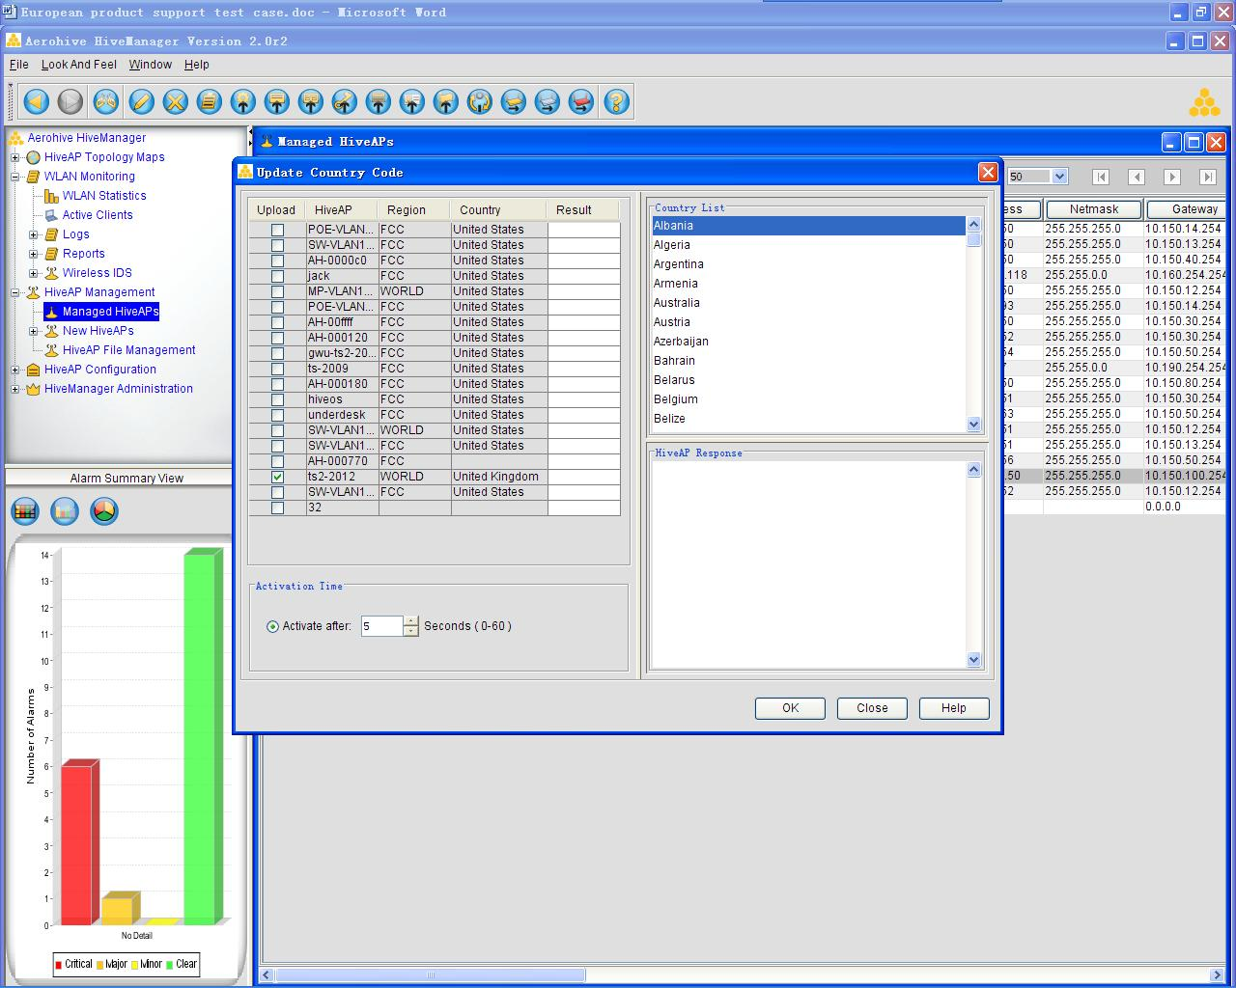

3. Test Points and Strategies
  - CLI check
    - Boot-param region-code [fcc| world]
pass-yypan

3.1.2 Boot-param country-code <number>
pass-yypan

3.2 Check region code and country code after reset configure
pass-yypan

3.3 Check region code and country code default setting
pass-yypan

3.4 Check channel setting when region code is set to ‘fcc’.
pass-yypan

3.5 When region code is set to fcc, country code can’t be modified
pass-yypan

3.6 Check every country’s channel and power setting when set region code to ‘world’.
pass-yypan

3.7 Check acsp function when set country code out side of US.
pass-yypan

3.8 Check power control function when set country code out of US.
pass-yypan

3.9 CLI check for auto roaming
- Radio profile <name> laod-balance roaming-threshold {[numbers] | very-low | low | medium | high}

3.10 Check auto roaming function when set roaming-threshold to:
- <numbers> -75 ~ -95dBm
- Very low
- Low
- Medium
- high

3.11 Check auto roaming default setting Ligang

3.12 Check box’s channel when user didn’t set country code after set region code to world

3.13 NMS test

3.1.3.1 GUI test
- AP selection window
- Country selection window
- Activation time window
- HiveAP response window

3.1.3.2 Country code setting test
- When the box region code is FCC, we can’t change the country code
- When the box region code is world, country code only can be set once.

3.1.3.3 HiveAP response information
- Success information
- Fail information

3.1.3.4 Check WiFi0 and wifi1 channel after change country code

4. Test Topology

4.1 Test Topology 1

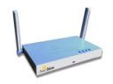
AP1

4.2 Test Topology 2
AP1

AP2
AP3

5. Software Tools Requirements
- Aeropeek (WiFi Packets Sniffer)
- Airmegnet
- Odyssey Client (Includes all Authentication Methods)

6. Hardware Requirements
- Stations
- Aerohive APs at least 3

7. Test Schedule

8. Test Case

CLI check: Boot-param region-code [fcc| world]
Case ID | CountryRegulation_Cli_1
Priority | Accept | Automation Flag | No
Topology to use
Description | CLI check: Boot-param region-code [fcc| world]
Pre-condition
Test procedure | 1.set region code to fcc, verify country code  2.set region code to world
Expect result | 1.when set region code to fcc, country code should be 840  2.when set region code to world, box should display handling tips to ask user set country code

CLI check: Boot-param country-code [numbers]
Case ID | CountryRegulation_Cli_2
Priority | Middle | Automation Flag | No
Topology to use
Description | CLI check: Boot-param country-code [numbers]
Pre-condition
Test procedure | 1.set country code of ISO 3166  2.set country code out of ISO 3166
Expect result | 1.When set an error country code error message should appear.

Check region code and country code after reset configure
Case ID | CountryRegulation_Function_1
Priority | High | Automation Flag | No
Topology to use
Description | Check region code and country code after reset configure
Pre-condition
Test procedure | 1.reset configure  2.reboot box  3.check region code and country code
Expect result | 1.region code and country code should be same with reset before.

Check region code and country code default setting
Case ID | CountryRegulation_Function_2
Priority | Accept | Automation Flag | No
Topology to use
Description | Check region code and country code default setting
Pre-condition
Test procedure | 1.Reset Configuration  2. show boot-param region code
Expect result | 1.region code should be fcc

Check channel setting when region code is set to ‘fcc’.
Case ID | CountryRegulation_Function_3
Priority | High | Automation Flag | No
Topology to use
Description | Check channel setting when region code is set to ‘fcc’.
Pre-condition
Test procedure | 1.set region code to fcc.  2.show interface wifi1 channel
Expect result | 2.wifi1 channel should correspond with standard.

When set region code to fcc, country code can’t be modified
Case ID | CountryRegulation_Function_4
Priority | High | Automation Flag | No
Topology to use
Description | When set region code to fcc, country code can’t be modified
Pre-condition
Test procedure | 1.set region code to fcc  2.excute cli: boot-param country-code 826
Expect result | 1.error message should display after cli is excuted

Check every country’s channel and power when set country code to “world”
Case ID | CountryRegulation_Function_5
Priority | Low | Automation Flag | No
Topology to use
Description | Check every country’s channel and power when set country code to “world”
Pre-condition
Test procedure | 1.set country code 826/784/702/682/458/410/392/554  2.check channel and power setting
Expect result | 1.channel and power should obey according country’s restrict.

Check acsp function when set country out of US
Case ID | CountryRegulation_Function_6
Priority | Low | Automation Flag | No
Topology to use
Description | Check acsp function when set country out of US.
Pre-condition
Test procedure | 1.set country code  2.check acsp function, available channel list
Expect result | 1.acsp should only select the channel of current country.

Check power control function when set country code out of US.
Case ID | CountryRegulation_Function_7
Priority | Low | Automation Flag | No
Topology to use
Description | Check power control function when set country code out of US.
Pre-condition
Test procedure | 1.set country code  2.check power control
Expect result | Same as US

auto roaming function test
Case ID | CountryRegulation_Function_8
Priority | Low | Automation Flag | No
Topology to use | Topology 1
Description | auto roaming function test
Pre-condition
Test procedure | 1.set country code  2.Check auto roaming function, check all levels.
Expect result | 1.AP should kick the station which RSSI is below threshold.

Check box’s channel when didn’t set country code after set region code to world
Case ID | CountryRegulation_Function_10
Priority | High | Automation Flag | No
Topology to use | Topology 1
Description | Check box’s channel when didn’t set country code after set region code to world
Pre-condition
Test procedure | 1.set region code to world  2.do some acsp and channel setting
Expect result | No change.

GUI: AP selection window
Case ID | CountryRegulation_GUI_1
Priority | Accept | Automation Flag | No
Topology to use | Topology 3
Description | GUI: AP selection window
Pre-condition | Hivemanger has find all three APs in topology 3, and three APs are in managed HiveAPs
Test procedure | - right click AP1 in Hivemanager managed HiveAPs, select [Hiveap update] →[Updata Country Code]  - Check AP selection window, user should can select one or multiple APs
Expect result | user should can select one or multiple APs

GUI: Country selection window
Case ID | CountryRegulation_GUI_2
Priority | Accept | Automation Flag | No
Topology to use | Topology 1
Description | GUI: Country selection window
Pre-condition | Hivemanger has find AP1, and AP1 is in managed HiveAPs
Test procedure | - right click AP1 in Hivemanager managed HiveAPs, select [Hiveap update] →[Updata Country Code]  - Check country selection window
Expect result | Country list all countries our box support

GUI: Activation time window
Case ID | CountryRegulation_GUI_3
Priority | High | Automation Flag | No
Topology to use | Topology 1
Description | GUI: Activation time window
Pre-condition | Hivemanger has find AP1, and AP1 is in managed HiveAPs
Test procedure | - right click AP1 in Hivemanager managed HiveAPs, select [Hiveap update] →[Updata Country Code]  - Check Activation time window, user can set 0~60 second time delay.
Expect result

GUI: Activation time window
Case ID | CountryRegulation_GUI_4
Priority | High | Automation Flag | No
Topology to use | Topology 1
Description | GUI: Activation time window
Pre-condition | Hivemanger has find AP1, and AP1 is in managed HiveAPs
Test procedure | - right click AP1 in Hivemanager managed HiveAPs, select [Hiveap update] →[Updata Country Code]  - Check Activation time window, user can set 0~60 second time delay.
Expect result

GUI: HiveAP response window
Case ID | CountryRegulation_GUI_5
Priority | Middle | Automation Flag | No
Topology to use | Topology 1
Description | GUI: HiveAP response window
Pre-condition | Hivemanger has find AP1, and AP1 is in managed HiveAPs
Test procedure | - right click AP1 in Hivemanager managed HiveAPs, select [Hiveap update] →[Updata Country Code]  - select a country to update, check the response information(success)  - shutdown AP1 eth0 interface, make AP1 lost in hivemanager managed APs.  - update country, check fail response information
Expect result

GUI: counry code setting test, region code is FCC
Case ID | CountryRegulation_GUI_6
Priority | Middle | Automation Flag | No
Topology to use | Topology 1
Description | GUI: counry code setting test, region code is FCC
Pre-condition | Hivemanger has find AP1, and AP1 is in managed HiveAPs
Test procedure | - configure AP1 region code to FCC then reboot AP1  - right click AP1 in Hivemanager managed HiveAPs, select [Hiveap update] →[Updata Country Code]  - select a country to update, error message should appear
Expect result

GUI: counry code setting test, region code is world
Case ID | CountryRegulation_GUI_7
Priority | Accept | Automation Flag | No
Topology to use | Topology 1
Description | GUI: counry code setting test, region code is world
Pre-condition | Hivemanger has find AP1, and AP1 is in managed HiveAPs
Test procedure | - configure AP1 region code to world, country code to 0  - reboot AP1  - right click AP1 in Hivemanager managed HiveAPs, select [Hiveap update] →[Updata Country Code]  - select a country to update  - after AP1 reboot, check country code by CLI:  show boot-param country-code
Expect result

GUI: counry code setting test, region code is world
Case ID | CountryRegulation_GUI_8
Priority | Middle | Automation Flag | No
Topology to use | Topology 1
Description | GUI: counry code setting test, region code is world
Pre-condition | Hivemanger has find AP1, and AP1 is in managed HiveAPs
Test procedure | - configure AP1 region code to world, country code to ***  - reboot AP1  - right click AP1 in Hivemanager managed HiveAPs, select [Hiveap update] →[Updata Country Code]  - select a country to update, error message should appear
Expect result

GUI: channel and power test of different country
Case ID | CountryRegulation_GUI_9
Priority | High | Automation Flag | No
Topology to use | Topology 1
Description | GUI: channel and power test of different country
Pre-condition | Hivemanger has find AP1, and AP1 is in managed HiveAPs
Test procedure | - configure AP1 region code to world, country code to 826/784/702/682/458/410/392/554  - reboot AP1  - check channel and power setting in interface window, the channel should comply with the frequency range in country ***, refer to “  Global_Frequency_Allocation.PDF” from Atheros  - change the country code and repeat step 2 and 3.
Expect result

Country code our box supported

CTRY_ALBANIA = 8, /* Albania */ doesn’t support 11a
CTRY_ALGERIA = 12, /* Algeria */ doesn’t support 11a
CTRY_ARGENTINA = 32, /* Argentina */ doesn’t support 11g
CTRY_ARMENIA = 51, /* Armenia */
CTRY_AUSTRALIA = 36, /* Australia */
CTRY_AUSTRIA = 40, /* Austria */
CTRY_AZERBAIJAN = 31, /* Azerbaijan */
CTRY_BAHRAIN = 48, /* Bahrain */
CTRY_BELARUS = 112, /* Belarus */
CTRY_BELGIUM = 56, /* Belgium */
CTRY_BELIZE = 84, /* Belize */
CTRY_BOLIVIA = 68, /* Bolivia */
CTRY_BOSNIA_HERZEGOWINA = 70, /* Bosnia and Herzegowina */
CTRY_BRAZIL = 76, /* Brazil */
CTRY_BRUNEI_DARUSSALAM = 96, /* Brunei Darussalam */
CTRY_BULGARIA = 100, /* Bulgaria */
CTRY_CANADA = 124, /* Canada */
CTRY_CHILE = 152, /* Chile */
CTRY_CHINA = 156, /* People's Republic of China */
CTRY_COLOMBIA = 170, /* Colombia */
CTRY_COSTA_RICA = 188, /* Costa Rica */
CTRY_CROATIA = 191, /* Croatia */
CTRY_CYPRUS = 196,
CTRY_CZECH = 203, /* Czech Republic */
CTRY_DENMARK = 208, /* Denmark */
CTRY_DOMINICAN_REPUBLIC = 214, /* Dominican Republic */
CTRY_ECUADOR = 218, /* Ecuador */
CTRY_EGYPT = 818, /* Egypt */
CTRY_EL_SALVADOR = 222, /* El Salvador */
CTRY_ESTONIA = 233, /* Estonia */
CTRY_FAEROE_ISLANDS = 234, /* Faeroe Islands */
CTRY_FINLAND = 246, /* Finland */
CTRY_FRANCE = 250, /* France */
CTRY_FRANCE2 = 255, /* France2 */
CTRY_GEORGIA = 268, /* Georgia */
CTRY_GERMANY = 276, /* Germany */
CTRY_GREECE = 300, /* Greece */
CTRY_GUATEMALA = 320, /* Guatemala */
CTRY_HONDURAS = 340, /* Honduras */
CTRY_HONG_KONG = 344, /* Hong Kong S.A.R., P.R.C. */
CTRY_HUNGARY = 348, /* Hungary */
CTRY_ICELAND = 352, /* Iceland */
CTRY_INDIA = 356, /* India */
CTRY_INDONESIA = 360, /* Indonesia */
CTRY_IRAN = 364, /* Iran */
CTRY_IRAQ = 368, /* Iraq */
CTRY_IRELAND = 372, /* Ireland */
CTRY_ISRAEL = 376, /* Israel */
CTRY_ITALY = 380, /* Italy */
CTRY_JAMAICA = 388, /* Jamaica */
CTRY_JAPAN = 392, /* Japan */
CTRY_JAPAN1 = 393, /* Japan (JP1) */
CTRY_JAPAN2 = 394, /* Japan (JP0) */
CTRY_JAPAN3 = 395, /* Japan (JP1-1) */
CTRY_JAPAN4 = 396, /* Japan (JE1) */
CTRY_JAPAN5 = 397, /* Japan (JE2) */
CTRY_JAPAN6 = 399, /* Japan (JP6) */

CTRY_JAPAN7 = 4007, /* Japan (J7) */
CTRY_JAPAN8 = 4008, /* Japan (J8) */
CTRY_JAPAN9 = 4009, /* Japan (J9) */

CTRY_JAPAN10 = 4010, /* Japan (J10) */
CTRY_JAPAN11 = 4011, /* Japan (J11) */
CTRY_JAPAN12 = 4012, /* Japan (J12) */

CTRY_JAPAN13 = 4013, /* Japan (J13) */
CTRY_JAPAN14 = 4014, /* Japan (J14) */
CTRY_JAPAN15 = 4015, /* Japan (J15) */

CTRY_JAPAN16 = 4016, /* Japan (J16) */
CTRY_JAPAN17 = 4017, /* Japan (J17) */
CTRY_JAPAN18 = 4018, /* Japan (J18) */

CTRY_JAPAN19 = 4019, /* Japan (J19) */
CTRY_JAPAN20 = 4020, /* Japan (J20) */
CTRY_JAPAN21 = 4021, /* Japan (J21) */

CTRY_JAPAN22 = 4022, /* Japan (J22) */
CTRY_JAPAN23 = 4023, /* Japan (J23) */
CTRY_JAPAN24 = 4024, /* Japan (J24) */

CTRY_JORDAN = 400, /* Jordan */
CTRY_KAZAKHSTAN = 398, /* Kazakhstan */
CTRY_KENYA = 404, /* Kenya */
CTRY_KOREA_NORTH = 408, /* North Korea */
CTRY_KOREA_ROC = 410, /* South Korea */
CTRY_KOREA_ROC2 = 411, /* South Korea */
CTRY_KOREA_ROC3 = 412, /* South Korea */
CTRY_KUWAIT = 414, /* Kuwait */
CTRY_LATVIA = 428, /* Latvia */
CTRY_LEBANON = 422, /* Lebanon */
CTRY_LIBYA = 434, /* Libya */
CTRY_LIECHTENSTEIN = 438, /* Liechtenstein */
CTRY_LITHUANIA = 440, /* Lithuania */
CTRY_LUXEMBOURG = 442, /* Luxembourg */
CTRY_MACAU = 446, /* Macau */
CTRY_MACEDONIA = 807, /* the Former Yugoslav Republic of Macedonia */
CTRY_MALAYSIA = 458, /* Malaysia */
CTRY_MALTA = 470, /* Malta */
CTRY_MEXICO = 484, /* Mexico */
CTRY_MONACO = 492, /* Principality of Monaco */
CTRY_MOROCCO = 504, /* Morocco */
CTRY_NETHERLANDS = 528, /* Netherlands */
CTRY_NEW_ZEALAND = 554, /* New Zealand */
CTRY_NICARAGUA = 558, /* Nicaragua */
CTRY_NORWAY = 578, /* Norway */
CTRY_OMAN = 512, /* Oman */
CTRY_PAKISTAN = 586, /* Islamic Republic of Pakistan */
CTRY_PANAMA = 591, /* Panama */
CTRY_PARAGUAY = 600, /* Paraguay */
CTRY_PERU = 604, /* Peru */
CTRY_PHILIPPINES = 608, /* Republic of the Philippines */
CTRY_POLAND = 616, /* Poland */
CTRY_PORTUGAL = 620, /* Portugal */
CTRY_PUERTO_RICO = 630, /* Puerto Rico */
CTRY_QATAR = 634, /* Qatar */
CTRY_ROMANIA = 642, /* Romania */
CTRY_RUSSIA = 643, /* Russia */
CTRY_SAUDI_ARABIA = 682, /* Saudi Arabia */
CTRY_SINGAPORE = 702, /* Singapore */
CTRY_SLOVAKIA = 703, /* Slovak Republic */
CTRY_SLOVENIA = 705, /* Slovenia */
CTRY_SOUTH_AFRICA = 710, /* South Africa */
CTRY_SPAIN = 724, /* Spain */
CTRY_SRI_LANKA = 144, /* Sri Lanka */
CTRY_SWEDEN = 752, /* Sweden */
CTRY_SWITZERLAND = 756, /* Switzerland */
CTRY_SYRIA = 760, /* Syria */
CTRY_TAIWAN = 158, /* Taiwan */
CTRY_THAILAND = 764, /* Thailand */
CTRY_TRINIDAD_Y_TOBAGO = 780, /* Trinidad y Tobago */
CTRY_TUNISIA = 788, /* Tunisia */
CTRY_TURKEY = 792, /* Turkey */
CTRY_UAE = 784, /* U.A.E. */
CTRY_UKRAINE = 804, /* Ukraine */
CTRY_UNITED_KINGDOM = 826, /* United Kingdom */
CTRY_UNITED_STATES = 840, /* United States */
CTRY_UNITED_STATES_FCC49 = 842, /* United States (Public Safety)*/
CTRY_URUGUAY = 858, /* Uruguay */
CTRY_UZBEKISTAN = 860, /* Uzbekistan */
CTRY_VENEZUELA = 862, /* Venezuela */
CTRY_VIET_NAM = 704, /* Viet Nam */
CTRY_YEMEN = 887, /* Yemen */
CTRY_ZIMBABWE = 716 /* Zimbabwe */

